YOUTH VISION INDIA · RESEARCH PAPER SERIES – 02

Young Minds, Strong Futures
Advancing Youth Mental Health, Social Connectedness and Community Resilience in India
Jagriti Sharma
Psychology Scholar · Research Writer · Educator
A Policy-Oriented Review and Original Framework
July 2026

Table of Contents
Table of Contents 2
Abstract 5
Executive Summary 6
Core Recommendation 6
Policy Message 6
1.1 Background 7
1.2 Research Gap 7
1.3 Research Objectives 7
1.4 Research Questions 8
1.5 Significance 8
1.6 Scope 8
2.1 Literature Review 9
2.1.1 Global Perspective 9
2.1.2 The Indian Context 9
2.1.3 Digital Transformation 9
2.1.4 Social Connectedness and Community Resilience 10
2.1.5 Gender in the Literature 10
2.1.6 Rural–Urban Disparity in the Literature 10
2.1.7 Research Gap 11
2.2 Research Methodology 11
2.2.1 Research Design 11
2.2.2 Search Strategy 11
2.2.3 Sources of Data 11
2.2.4 Inclusion and Exclusion Criteria 12
2.2.5 Ethical Considerations 12
2.2.6 Limitations of the Methodology 12
3.1 Current Status of Youth Mental Health in India 13
3.2 Major Challenges Affecting Youth Mental Health 14
3.2.1 Academic Pressure and Career Uncertainty 14
3.2.2 Digital Lifestyle and Cyberbullying 14
3.2.3 Family Expectations and Loneliness 14
3.2.4 Substance Use and Suicide Risk 14
3.3 Voices from the Field 15
3.3.1 Practitioner Reflections 15
3.3.2 Illustrative Field Scenarios 16
4.1 Gender Perspective: Boys vs. Girls 17
4.1.1 Gender Differences in Help-Seeking Behaviour 17
4.2 Rural Perspective: Beyond Urban India 18
4.2.1 Mental Health Challenges among Rural Young Women 19
4.3 Generational Comparison: The Earlier Generation vs. Today's Youth 19
4.4 Social Connectedness and Community Resilience 20
5.1 Introduction 22
5.2 NMHP 22
5.3 DMHP 22
5.4 The Mental Healthcare Act, 2017 22
5.5 Tele-MANAS 23
5.6 Mental Health in Educational Institutions 23
5.7 Youth Mental Health and the Sustainable Development Goals 24
5.8 Policy Gaps and Emerging Challenges 24
5.9 International Good Practices 25
Critical Analysis 25
6.1 Introduction 27
6.2 Policy Recommendations 27
1. Strengthen Mental Health Education 27
2. Expand Accessible Counselling Services 27
3. Promote Community-Based Mental Health 27
4. Build Gender-Responsive Programmes 27
5. Invest in Digital Wellbeing and Cyber Safety 28
6. A Dedicated Rural Implementation Pathway 28
7. Encourage Youth Participation 28
6.3 Proposed Framework: The VARIKA Framework 28
6.3.1 Framework Validation and Comparative Positioning 29
6.4 Practical Implications by Stakeholder 30
7.1 Conclusion 32
7.1.1 Contribution of the Study 32
7.2 Limitations of the Study 32
7.3 Future Scope of Research 33
Author's Perspective 33
Acknowledgement 34
References 35

Abstract
Mental health has become one of the most important public health and development concerns of our time. India, home to one of the world's largest youth populations, is going through fast social, technological, educational, and economic change. This change has created new opportunities for learning and work, but it has also brought new psychological pressures for young people, academic competition, career uncertainty, heavy digital use, changing family relationships, loneliness, financial insecurity, and online harassment among them.
According to the National Mental Health Survey conducted by NIMHANS (2016), close to 7.3% of adolescents aged 13–17 years in India experience a diagnosable mental disorder, and nearly 15% of Indian adults need active support for one or more mental health conditions. Despite rising awareness, access to quality mental healthcare remains uneven, especially in rural and low-income areas, where trained counsellors and psychiatrists are scarce.
Young women often carry an extra layer of pressure linked to safety, family expectations, online harassment, and unequal opportunity. Rural youth, meanwhile, face a different set of barriers, limited awareness, weak infrastructure, social stigma, and distance from professional help. These patterns show that youth mental health cannot be understood through one lens alone.
This paper presents a multidisciplinary, policy-oriented review of youth mental health in India, supplemented by brief, illustrative insights from two practitioners working directly with adolescents. It draws on government data (NIMHANS, the Ministry of Health and Family Welfare, the National Crime Records Bureau, and the National Education Policy 2020), international sources (WHO, UNICEF), and peer-reviewed research to examine the present situation, compare the experience of boys and girls, compare today's generation with the one before it, evaluate government programs such as Tele-MANAS, and propose a practical six-pillar model, the VARIKA Framework (Vigilance, Awareness, Relationships, Integration, Kinship, and Access), for building a more preventive, inclusive, and community-centered mental health system for India's youth. The VARIKA Framework is a conceptual framework proposed by the author for this study and positioned against the WHO/UNICEF Helping Adolescents Thrive programs, with a defined pathway for the future empirical validation.
Keywords
Youth Mental Health; Social Connectedness; Community Resilience; Gender and Mental Health; Rural–Urban Disparity; Tele-MANAS; Public Policy; Digital Wellbeing; India.

Executive Summary
Youth mental health in India sits at the intersection of psychology, education, gender, rural development, and public policy. This paper reviews government data, national and international reports, and peer-reviewed research, alongside brief illustrative input from two practitioners in the field, to build a practical, policy-ready picture of where the things stand today, and what should happen next.
Key Findings
- Close to 7.3% of Indian adolescents (13–17 years) live with a diagnosable mental disorder, and nearly 15% of adults need active mental health support (Gururaj et al., 2016).
- Boys and girls face different and shifting risks: male students still account for the larger share of student suicides, but female student suicides are rising faster year-on-year (National Crime Records Bureau, 2021, 2022).
- Rural youth face structural barriers, distance, cost, and stigma, which urban youth do not face in the same way, even as rural communities offer strong informal support networks (Verma & Kumar, 2024).
- Today's generation carries different pressures than the one before it: digital exposure has grown from about 545 million internet users in 2010 to over a billion by 2025–26, alongside far greater (though still incomplete) mental health awareness (Data Reportal, 2025).
- Tele-MANAS has grown from 12,000 monthly calls in December 2022 to nearly 30 lakh cumulative calls by November 2025, but broader government programs and law (NMHP, DMHP, MHCA 2017, NEP 2020) still face uneven implementation and rural reach (Ministry of Health and Family Welfare, 2025; “Bridging the Mental Health Treatment Gap,” 2025).

Core Recommendation
The paper proposes the VARIKA Framework, built on six pillars: Vigilance, Awareness, Relationships, Integration, Kinship, and Access, to guide future programs toward prevention, early support, and community partnership, rather than treatment alone. Full details, data tables, charts, and references follow in the sections ahead.

Policy Message
Policy Perspective. India needs one coordinated mental health system, not more isolated schemes. Rural and gender-specific gaps require targeted, not generic, solutions, and legal rights under the Mental Healthcare Act, 2017 must translate into functioning services on the ground. Every new initiative should be tested against the VARIKA Framework's six pillars, Vigilance, Awareness, Relationships, Integration, Kinship, and Access, moving together, not separately.

1. INTRODUCTION

1.1 Background
Mental health shapes how a person thinks, feels, learns, and relates to others. For young people, adolescence and early adulthood are a critical stretch of life, a period when the brain, emotions, and social identity are still forming. What happens during these years often shapes the decades that follow.
India's young population is one of its biggest strengths. Nearly two-thirds of Indians are under the age of 35. But this advantage can only be realized if young people are emotionally resilient and socially connected, not just physically healthy. Rapid technological change, intense academic competition, unstable job markets, and shifting family structures have added new sources of stress that earlier generations did not have to navigate in the same way.
Until recently, mental health in India was discussed mostly inside hospitals and clinics, which is changing. Schools, colleges, civil society groups, digital platforms, and government agencies are now part of the conversation. Yet stigma, misinformation, and delayed help-seeking still stop many young people, especially young women, students from low-income families, and those living in rural areas, from getting support early enough.

1.2 Research Gap
A lot of existing research treats depression, anxiety, stress, or digital addiction as separate problems. Fewer studies look at how family support, school environment, community life, and public policy work together, or at how experiences differ by gender and geography. Much of the available literature is also urban-focused, leaving rural youth under-represented, and it rarely asks how today's generation differs from the one before it in terms of stress, connectivity, and coping. This paper tries to fill that gap by bringing psychology, education, gender studies, rural development, and public policy into a single, practical framework.

1.3 Research Objectives
This study was carried out with the following objectives:
- To examine the current state of youth mental health in India using recent government data and reports.
- To identify the main psychological, social, educational, and digital factors affecting young people's mental wellbeing.
- To understand how family support, education, and community life help build resilience among youth.
- To compare the mental health experience of young women and young men, and of rural and urban youth.
- To compare how today's generation of young Indians experiences mental health differently from the generation before it.
- To evaluate government programs such as the National Mental Health Programme and Tele-MANAS.
- To propose practical, evidence-based policy recommendations and a workable framework for the future.

1.4 Research Questions
- What are the biggest mental health challenges facing Indian youth today?
- Which factors, psychological, social, economic, or digital, affect young people the most?
- How do family, school, and community shape resilience in young people?
- How different are the experiences of young women compared with young men, and rural youth compared with urban youth?
- How has the mental health picture changed between the previous generation and today's generation?
- How effective are current government policies in improving access to mental healthcare?
- What steps can make India's mental health system more inclusive and community-centered?

1.5 Significance
India's youth will shape the country's workforce, leadership, and social fabric for decades to come. Investing in their mental wellbeing is therefore not just a health issue, it is an investment in the nation's future. While awareness has grown in recent years, gaps in early identification, timely support, and equal access remain wide, particularly for rural communities and young women.
Unlike studies that look only at the clinical side of mental illness, this paper takes a broader view. It links psychology with education, rural development, gender, and public policy, and it pays close attention to two comparisons that are often missing from the conversation: the difference between how boys and girls experience mental health pressure, and the difference between the generation that grew up before smartphones and the generation growing up with them.

1.6 Scope
This paper draws on secondary sources, including government reports, publications of recognized national and international bodies, and peer-reviewed research, supplemented by brief illustrative input from two practitioners in the field (see Section 2 for methodology). It covers adolescents and young adults in India, looking at psychological, educational, social, digital, gender, and policy dimensions together rather than in isolation, with a focus on prevention and community support rather than treatment alone. It is organized into seven sections, moving from this introduction and literature review, through the current situation and its challenges, to a gender, rural, and generational comparison, a review of government policy, and finally a set of recommendations and a proposed framework.

2. LITERATURE REVIEW AND METHODOLOGY

2.1 Literature Review

2.1.1 Global Perspective
The World Health Organization (WHO) treats mental health as a core part of overall health, not an add-on (World Health Organization, 2022). This landmark report has been described as a message of hope for global mental health reform, urging countries to move from institutional, treatment-only models toward promotion and prevention across the life course (Saraceno & de Almeida, 2022). Global evidence shows that many mental health conditions begin before adulthood, which makes adolescence a key window for prevention and early support (World Health Organization, 2021, 2024). International guidance increasingly favors combining healthcare, education, family support, and community participation, rather than relying on hospitals and clinics alone (World Health Organization & UNICEF, 2022).
Taken together, these global reports point to adolescence as the single most cost-effective window for the mental health intervention. Yet most national systems, India's included, still invest primarily in adult clinical care rather than youth-focused prevention. This paper therefore treats the adolescent and young-adult years as the central point of intervention, not an afterthought.

2.1.2 The Indian Context
India-specific research shows a similar pattern: rising anxiety, depression, academic stress, and substance use among young people, driven by examination pressure, family expectations, financial strain, and changing lifestyles (Balamurugan et al., 2024; Malhotra & Patra, 2014). The 2015–16 National Mental Health Survey by NIMHANS found that current mental disorders affected roughly 7.3% of adolescents aged 13–17, with rates broadly similar between boys and girls at this age, and that close to 15% of Indian adults required active intervention for at least one mental health condition (Gururaj et al., 2016). UNICEF's flagship review similarly estimated that around 50 million Indian children lived with mental health concerns even before the pandemic, with 80–90% of them never receiving support (UNICEF, 2021), and a subsequent service-mapping exercise found child and adolescent mental health services still concentrated in a small number of states and large cities (UNICEF India, 2024). Fear of stigma and shortage of trained professionals continue to delay treatment, and these barriers are sharper in poorer and rural populations (The George Institute for Global Health, 2026a).
A consistent and troubling pattern emerges from these Indian studies: prevalence estimates are high, but treatment-seeking remains extremely low. Most of this evidence, however, is drawn from urban, clinic-based samples, so the true scale of untreated distress among rural and lower-income youth is very likely under-counted rather than accurately captured.

2.1.3 Digital Transformation
Smartphones, social media, and online education have reshaped how young Indians learn, socialize, and spend their time. Research links excessive or unhealthy digital use with poor sleep, unrealistic social comparison, fear of missing out, and lower self-esteem (Gao & Gao, 2024). Systematic reviews report that heavier screen time and problematic social media use are associated with higher depression and anxiety symptoms, with the association often stronger for adolescent girls than boys. At the same time, technology itself is not the villain, the effect depends heavily on how, how much and why it is used.
On the whole, the digital-wellbeing literature suggests a dose- and content-dependent relationship rather than a simple “screens are harmful” conclusion, though few Indian studies have tested this relationship directly. This paper accordingly treats digital exposure as a risk-modifier to be managed through literacy and healthy-use guidance, rather than a factor that can or should be eliminated.

2.1.4 Social Connectedness and Community Resilience
A consistent finding across studies is that strong relationships, with family, teachers, peers, and community, protect young people against stress and loneliness (Ranjith et al., 2019). Community resilience research adds that schools, neighborhoods, youth groups, and local institutions, not hospitals alone, shape how well young people cope with hardship (World Health Organization & UNICEF, 2022).
These studies, read together, indicate that relationships function as a buffer against most of the stressors identified elsewhere in this review. This protective effect, though, is rarely built into formal Indian mental health policy in a structured way, which is why this paper treats social connectedness as a policy lever in its own right, not merely a background condition.

2.1.5 Gender in the Literature
Studies repeatedly find that young women face a distinct mix of pressures: educational expectations, safety concerns, online harassment, body-image pressure, and unpaid caregiving (“Effects of Cyberbullying Victimization,” 2022). Indian cyberbullying research shows that girls report higher victimization and psychological harm from online harassment, while boys are more often identified as perpetrators of cyberbullying and face-to-face aggression (Cyberbullying Research Center, 2023; Silent Screams, 2024). Researchers now recommend gender-sensitive rather than gender-neutral program design, while also recognizing that education and economic participation build resilience among young women.
This body of work makes clear that gender shapes both the type of risk faced and the willingness to seek help, yet very few Indian interventions are designed separately for boys and girls. This paper accordingly argues for gender-responsive rather than one-size-fits-all program design, discussed further in Section 4 and Section 6.

2.1.6 Rural–Urban Disparity in the Literature
Urban India generally has more psychiatrists, psychologists, and counselling centers; rural India continues to face shortages of trained professionals, weaker awareness, and greater stigma. Nationally, India has only about 0.75 psychiatrists per 100,000 people against a global median of roughly 1.3, and this workforce is heavily concentrated in cities (Verma & Kumar, 2024; “Mapping of Geographic Inequality,” 2025). Tele-MANAS and similar digital services have narrowed this gap somewhat, but literature cautions that digital services alone cannot replace investment in local healthcare and community awareness (“Bridging the Mental Health Treatment Gap,” 2025).
These findings, in short, point to geography, not just awareness, as a primary driver of India's mental health treatment gap. Telehealth expansion has outpaced investment in rural, in-person infrastructure, so this paper treats rural service delivery as a distinct policy problem requiring its own solutions, rather than one that digital tools alone can resolve.

2.1.7 Research Gap
Few studies bring psychology, education, gender, rural development, community resilience, and public policy together in one framework, and fewer still compare generations directly. This paper is designed to close that gap.

2.2 Research Methodology

2.2.1 Research Design
This is a qualitative, descriptive, and policy-oriented study based primarily on secondary data, supplemented by a small number of informal practitioner consultations. Alongside its synthesis of government reports, international organizations, and peer-reviewed research, the paper draws on brief field input from a school counsellor and a youth NGO field coordinator, used illustratively to ground the secondary evidence in practice-level experience rather than as a systematic primary dataset. The two practitioners were selected through purposive sampling, based on their direct professional experience with adolescent mental health and youth engagement in school and community settings; consultations took the form of semistructured informal discussions conducted between June and July 2026.

2.2.2 Search Strategy
Evidence for this review was identified through structured searches of the following sources, conducted between January and July 2026:
- Databases and repositories searched: PubMed, Google Scholar, ScienceDirect (Elsevier), Springer, Scopus-indexed journals via publisher sites, the WHO Library (IRIS), and official Government of India data portals.
- Search terms used (individually and in combination): “youth mental health India”, “adolescent depression India”, “cyberbullying gender India”, “rural mental health access India”, “Tele-MANAS”, “Mental Healthcare Act 2017”, “screen time adolescent mental health”, and “Sustainable Development Goals mental health”.
- Inclusion window: publications and reports dated 2014–2026, with a small number of older foundational sources (e.g., the original NMHP and DMHP documentation) retained for historical context.
- Screening approach: titles and abstracts were reviewed for relevance to Indian youth (age approximately 10–24) and to the paper's six themes, prevalence, gender, rural access, digital wellbeing, policy, and community resilience, before a source was included.

2.2.3 Sources of Data
Data and evidence for this paper were drawn from:
- Ministry of Health and Family Welfare, Government of India
- National Institute of Mental Health and Neurosciences (NIMHANS), National Mental Health Survey, 2015–16
- Tele-MANAS official reports and press releases
- National Crime Records Bureau (NCRB), Accidental Deaths and Suicides in India (ADSI) reports
- Ministry of Education, National Education Policy (NEP), 2020
- World Health Organization (WHO) and UNICEF
- Peer-reviewed journal articles and independent research reports (e.g., IC3 Institute)

2.2.4 Inclusion and Exclusion Criteria
The study includes official government reports, publications from recognized international organizations, and peer-reviewed research focused on adolescents and young adults. It excludes unverified blogs, opinion pieces without evidence, and commercial content without credible sourcing.

2.2.5 Ethical Considerations
Two practitioners working with adolescents were consulted informally and agreed to have their observations quoted; their input is illustrative rather than the product of a systematic qualitative study, and no formal human-subjects protocol or clearance was therefore required. Both contributors' fields and roles are described without identifying details, at their request. All sources are credited using APA (7th edition) referencing, and every effort has been made to present findings objectively and without personal bias.

2.2.6 Limitations of the Methodology
Because the study relies mainly on secondary sources, supplemented only by brief, informal input from two practitioners, it cannot capture new primary data at the scale of a systematic survey or interview study. Differences in how various reports measure and define mental health conditions also make some comparisons approximate rather than exact. Readers should treat the figures in this paper as indicative of scale and direction rather than precise, real-time counts, and consult the original government sources for the latest updates.

3. CURRENT STATUS AND MAJOR CHALLENGES

3.1 Current Status of Youth Mental Health in India
India's mental health picture is a mix of progress and unmet need. Awareness has grown steadily over the past decade, research has expanded, and government attention has increased. Yet mental health conditions among adolescents and young adults remain common, driven by academic competition, employment uncertainty, changing family structures, financial pressure, rapid urbanization, heavy digital engagement, and the lingering effects of the COVID-19 pandemic.
The Government of India has responded with several programs, including the National Mental Health Programme (NMHP), the District Mental Health Programme (DMHP), and, more recently, the National Tele Mental Health Programme (Tele-MANAS). These have expanded access to counselling, particularly through telephone-based services, but urban–rural gaps in trained professionals and awareness persist. Table 1 summarizes the key indicators.
Table 1. Selected Indicators of Youth Mental Health in India
Indicator | Figure | Source
Adolescents (13–17 years) with a current mental disorder | 7.3% | NIMHANS, National Mental Health Survey, 2015–16
Indian adults needing active mental health intervention | ~15% | NIMHANS, National Mental Health Survey, 2015–16
Population share below age 35 | ~65% | Census of India / Government of India estimates
Tele-MANAS calls handled (cumulative, Nov 2025) | 29.82 lakh (2.98 million) | Ministry of Health & Family Welfare, Nov 2025
Tele-MANAS callers aged 18–45 years | ~70% | Ministry of Health & Family Welfare, 2025
Student suicides recorded (2022) | ~13,700 (approx.) | NCRB, Accidental Deaths & Suicides in India, 2022
Tele-MANAS Cells operating nationwide | 53 (across 36 States/UTs) | Ministry of Health & Family Welfare, Nov 2025
Note. Figures are drawn from the most recently published official reports at the time of writing (Gururaj et al., 2016; Ministry of Health and Family Welfare, 2025; National Crime Records Bureau, 2022) and should be re-checked against the latest NIMHANS / Government of India / Tele-MANAS releases before any further re-publication, as these are updated periodically.
A clear gap exists between awareness and access. Many young people today recognize that mental wellbeing matters, but professional services remain unevenly spread, rural areas face shortages of trained psychologists and psychiatrists, while urban areas often have long waiting times and high costs (Verma & Kumar, 2024). Treatment-focused responses still get more attention than prevention, even though early, low-cost support could stop many problems from becoming severe.

3.2 Major Challenges Affecting Youth Mental Health

3.2.1 Academic Pressure and Career Uncertainty
Board examinations, entrance tests, and competition for limited seats in top institutions create sustained pressure on Indian students, often from a young age (Malhotra & Patra, 2014). Many young people link their entire self-worth to exam results, which raises the emotional cost of failure. This pressure continues into early adulthood as career uncertainty, automation, a fast-changing job market, and economic swings make many graduates anxious about employability, even after years of academic effort. Young women in some settings face this stress alongside family expectations around marriage and safety, while rural youth often lack access to career guidance and professional networks.

3.2.2 Digital Lifestyle and Cyberbullying
Smartphones and social media have become central to how young Indians learn, socialize, and relax. Used well, they open doors to information and connection. Used poorly, they encourage constant comparison with curated online lives, reduce face-to-face interaction, and disturb sleep (Gao & Gao, 2024). Cyberbullying adds another layer of risk, unlike playground bullying, it can follow a young person home and continue through the night (“Predictors, Prevalence, and Patterns of Cyberbullying,” 2023). Young women are disproportionately targeted through cyberstalking, image-based harassment, and abusive messaging, and many hesitate to report such experiences out of fear or stigma (“Effects of Cyberbullying Victimization,” 2022).

3.2.3 Family Expectations and Loneliness
Family remains central to a young Indian's emotional world, usually a source of strength, but sometimes a source of pressure when expectations around academic or career success feel unrealistic. At the same time, despite constant online connection, many young people report loneliness. Migration for education or work, smaller nuclear families and heavy reliance on digital communication have reduced face-to-face bonding for many, and loneliness is linked to lower self-esteem, poor sleep, and reduced willingness to ask for help (Balamurugan et al., 2024).

3.2.4 Substance Use and Suicide Risk
Prolonged stress, loneliness and peer influence can push some young people towards alcohol, tobacco, or other substance use as a coping mechanism, which in turn worsens mental health outcomes over time. At the most serious end, suicide remains a major concern. NCRB data show that in 2022, male students accounted for about 53% of student suicides, while between 2021 and 2022 male student suicides fell by roughly 6% even as female student suicides rose by about 7%, a shift worth close policy attention (National Crime Records Bureau, 2021, 2022). Over the decade since 2012, male student suicides rose by about 99% and female student suicides by about 92% (IC3 Institute, 2024, citing NCRB data). Suicide is preventable in most cases through early identification, accessible counselling, and reduced stigma around help-seeking (World Health Organization, 2019).
Policy Perspective. Suicide prevention, substance-use prevention, and everyday mental health support should sit inside one integrated youth health program, not three separate schemes that rarely talk to each other.
Table 2. Major Challenges Affecting Youth Mental Health, a Summary
Challenge | What It Looks Like | Group Most Affected
Academic pressure | Fear of failure tied to exams and admissions | School and college students
Career uncertainty | Anxiety over jobs, automation, and income security | College students, fresh graduates
Digital lifestyle / cyberbullying | Comparison, FOMO, and online harassment | Teen and young-adult social media users
Family expectations | Pressure to meet parental academic/career hopes | Students, especially young women
Loneliness / isolation | Weak face-to-face bonds despite online contact | Urban migrants, nuclear-family youth
Substance use / suicide risk | Coping through substances; severe distress | Youth with untreated chronic stress
Key Findings
- Youth mental health is shaped by several overlapping factors, not one single cause.
- Academic pressure and career uncertainty remain the two most consistently reported stressors.
- Digital life cuts both ways, a support system for some, a source of harm for others.
- Male and female students show different and shifting suicide trends, which calls for gender-aware prevention strategies.
- Prevention and early support deserve as much attention as treatment.

3.3 Voices from the Field
To complement the secondary evidence reviewed above, the author collected brief, informal reflections from two practitioners working directly with adolescents. These inputs are illustrative rather than the product of a systematic qualitative study, and are presented here to ground the paper’s secondary findings in practice-level experience. Identifying details in the case scenarios below have been generalized to protect the individuals concerned.

3.3.1 Practitioner Reflections
“Most adolescents do not hesitate to seek help because of a lack of awareness, but because they fear being judged by their peers and families.”
– School Counsellor (identity withheld on request)
Key Insight: Perceived stigma remains a stronger barrier to help-seeking than a lack of information.
“In rural communities, parents often prioritize academic success over emotional wellbeing, making mental health conversations difficult to initiate.”
– Youth NGO Field Coordinator (identity withheld on request)
Key Insight: Family attitudes significantly influence adolescents’ willingness to access mental health support.

3.3.2 Illustrative Field Scenarios
Case A
A 16-year-old student experienced prolonged anxiety before board examinations but avoided counselling due to fear of being labelled “weak.” After participating in a school mental health awareness session, the student voluntarily sought counselling and reported improved coping strategies.
Learning: School-based awareness programs can reduce stigma and improve help-seeking behavior.
Case B
An NGO volunteer observed that adolescents attending regular peer-support sessions gradually became more comfortable discussing stress and emotional challenges, leading to increased referrals to professional counsellors.
Learning: Community-led peer support can act as an effective bridge to formal mental health services.

4. GENDER, RURAL PERSPECTIVE, AND GENERATIONAL COMPARISON

4.1 Gender Perspective: Boys vs. Girls
Mental health pressure does not land equally on boys and girls. The NIMHANS 2015–16 survey found broadly similar overall disorder rates between adolescent boys and girls, but the type of pressure, and how it is expressed, differs (Gururaj et al., 2016). Young women more often report anxiety linked to safety, body image, online harassment, and unequal opportunity; young men more often externalize stress through risk-taking, substance use, or reluctance to seek help at all because of masculinity-linked stigma (“Effects of Cyberbullying Victimization,” 2022).
NCRB suicide data illustrate a shifting pattern rather than a fixed one. In 2021, of roughly 13,089 recorded student suicides, about 7,396 were male students and 5,693 were female students (National Crime Records Bureau, 2021). By 2022, while male students still made up the larger share (about 53% of the total), the trend had begun to move, male student suicides fell by around 6% year-on-year while female student suicides rose by around 7% (National Crime Records Bureau, 2022). Over the longer 2012–2022 window, both male and female student suicides roughly doubled, with male cases rising slightly faster (about 99%) than female cases (about 92%) (IC3 Institute, 2024).
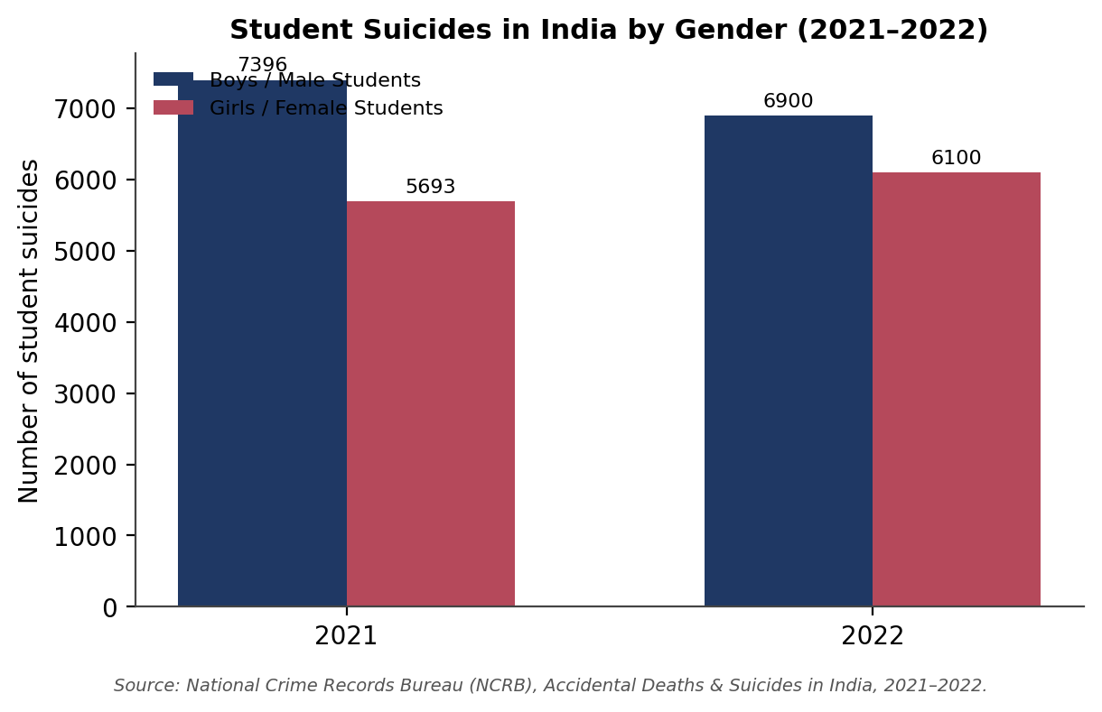
Figure 1. Student suicides in India by gender, 2021–2022 (approximate figures, rounded). Source: NCRB, Accidental Deaths & Suicides in India; IC3 Institute (2024).
These numbers do not tell us why any individual young person took their life, and they should never be read as a simple ranking of who “suffers more.” What they do show is that gender-blind policy is not good enough, support systems need to notice both the historically higher burden among young men and the fast-rising trend among young women, and respond to each with the right kind of outreach.

4.1.1 Gender Differences in Help-Seeking Behavior
Boys and girls do not just experience different pressures, they also face different barriers when it comes to actually reaching out for professional support. Young women are more likely to recognize and name their distress, but they often need a parent's permission or a family member to accompany them to a clinic, and they weigh the risk of being judged, gossiped about or considered “unmarriageable” if their visit to a counsellor becomes known locally (“Effects of Cyberbullying Victimization,” 2022). Concerns about confidentiality are especially acute when the underlying issue involves harassment, an unsafe relationship or family conflict, since young women often have less control over their own privacy and movement than young men do.
Young men, by contrast, are more likely to avoid help-seeking altogether. Masculinity-linked stigma frames emotional distress as a weakness rather than a health issue, so many young men underreport symptoms, mask distress through anger, risk-taking or substance use, and only come into contact with services after a crisis rather than through early, voluntary help-seeking (Malhotra & Patra, 2014). The result is a paradox worth flagging for policy: young women are somewhat more willing to acknowledge distress but face practical and social barriers to acting on it, while young men face fewer practical barriers but far stronger psychological and cultural resistance to seeking help at all. Effective outreach therefore needs two different strategies, not one common message, practical, confidential access for young women, and stigma-reduction aimed squarely at masculinity norms for young men.

4.2 Rural Perspective: Beyond Urban India
Most public conversation about youth mental health in India centers on cities, universities, and metropolitan hospitals. Yet a large share of India's youth live in rural and semi-rural areas, where mental health services are thin on the ground. A systematic review and meta-analysis of rural Indian adolescents found mental health problems in a substantial minority of the population studied, with anxiety and depressive symptoms among the most common (“Prevalence of Mental Health Problems Among Rural Adolescents,” 2022). As noted earlier, India's psychiatrist density remains far below the global median, and around 70% of these professionals practice in urban areas that hold less than 40% of the population (Verma & Kumar, 2024; “Mapping of Geographic Inequality,” 2025). Long distances to the nearest counsellor, weaker digital access in some regions, and stronger social stigma around discussing emotional problems all combine to keep rural help-seeking low, with treatment gaps exceeding 80% in some rural areas compared with about 60% in cities (Gururaj et al., 2016).
At the same time, rural India has real strengths that are often overlooked: closely-knit families, active community networks, respected local leaders, schools, self-help groups, and primary healthcare workers. Programs such as the Rashtriya Kishor Swasthya Karyakram (RKSK) already train peer educators and frontline health workers in villages, showing that community-based delivery is possible at scale (Ministry of Health and Family Welfare, 2014; Desai, 2017). When trained and supported, these existing institutions can become genuine partners in spotting distress early and offering the first line of emotional support, even before a professional is involved.
Table 3. Rural and Urban Youth: A Comparative Snapshot
Aspect | Urban Youth | Rural Youth
Access to psychiatrists/psychologists | Comparatively higher, though costly | Limited; long travel distances
Awareness of mental health services | Growing steadily | Improving slowly, still low in many areas
Main support system | Peers, counsellors, digital services | Family, community, primary health worker
Stigma around seeking help | Reducing, but still present | Comparatively higher
Tele-MANAS relevance | Useful supplement to in-person care | Often the main accessible option

4.2.1 Mental Health Challenges among Rural Young Women
Rural young women sit at the intersection of every barrier discussed so far, and the overlap makes their situation distinct rather than simply “rural plus female.” Stigma is compounded: admitting to emotional difficulty can be read locally as a failure of character, and this judgment tends to fall more heavily on unmarried young women, whose reputations and marriage prospects are seen as easily damaged by gossip. Counselling access is also thinner in practice than official statistics suggest, even where a district has a counsellor on paper, many rural young women are unwilling to see a male counsellor about personal or family matters, and trained female counsellors are scarce outside larger towns.
Education and mobility compound these gaps further. Lower secondary-school completion rates in some rural areas limit exposure to mental health literacy content delivered through schools, while restrictions on independent travel, whether from safety concerns or family expectations, mean many young women cannot reach even the services that do exist without a chaperone. The digital divide adds one more layer: women in rural India are consistently less likely than men to own a smartphone or have independent, private internet access, which limits how far Tele-MANAS and other digital services can actually reach this group in practice, whatever their official coverage on paper. Finally, family expectations around early marriage, household responsibilities and caregiving duties often leave rural young women with the least personal time, money and decision-making autonomy of any group discussed in this paper, precisely the resources most needed to act on a mental health concern once it is recognized.

4.3 Generational Comparison: The Earlier Generation vs. Today's Youth
A generation ago, most young Indians grew up with limited or no internet access, larger joint-family networks, and entertainment and information that came mainly from television, radio, print and face-to-face conversation. In 2010, India had around 545 million wireless/internet subscribers; by 2025–26, that number had grown to over 1 billion, alongside roughly 500 million active social media users (Data Reportal, 2025; GrabOn, 2026). Average daily time spent on social media apps in India is now estimated at around 2.5 hours, compared with negligible smartphone-based use fifteen years ago. Longitudinal evidence from this newer, always-online generation links heavier screen time with higher rates of depression and anxiety (Gao & Gao, 2024).
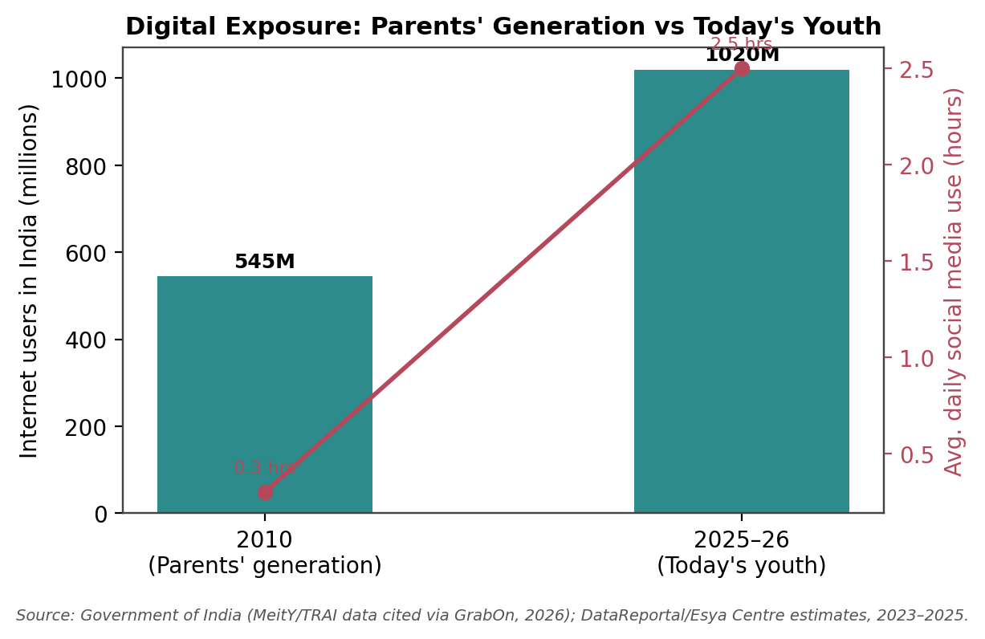
Figure 2. Digital exposure: the earlier generation (2010) versus today's youth (2025–26). Source: GrabOn/TRAI-based estimates (2026); DataReportal, Digital 2025: India; Esya Centre (2023).
This shift is not only about screen time. The earlier generation typically had slower access to information, but often stronger face-to-face community bonds and, in many cases, less individual academic pressure since fewer competitive options existed. Today's youth has far more information and opportunity at their fingertips, but also constant social comparison, a 24-hour news and content cycle, and awareness of a much wider range of career paths, which can be motivating, but also overwhelming.
Table 4. Comparing Two Generations of Indian Youth
Aspect | Earlier Generation (approx. 1990s–2000s) | Today's Generation (2010s–2020s)
Main information source | Television, radio, print, word of mouth | Smartphone, social media, streaming
Family structure | Larger joint/extended families common | Smaller, often nuclear families
Daily digital exposure | Minimal to none | Approx. 2–3 hours/day on social media
Academic competition | Present, but fewer competing options | Intense; many more courses, exams, comparisons
Awareness of mental health | Low; rarely discussed openly | Rising, though stigma still exists
Common stress source | Exams, limited career options | Exams, career uncertainty, online comparison, cyberbullying
The comparison suggests that today's youth are not simply “more stressed” than earlier generations, their stress has changed shape. Awareness of mental health has genuinely improved, which is progress. But so has exposure to constant comparison, information overload and digital forms of harassment that did not exist for their parents' generation in the same way.

4.4 Social Connectedness and Community Resilience
Across age groups and backgrounds, one finding holds steady: strong relationships protect mental health. Young people who feel supported by family, teachers and peers are more likely to ask for help early and cope better with setbacks (Ranjith et al., 2019). Community resilience, the ability of a school, neighborhood or local network to respond supportively to distress, works alongside professional healthcare rather than replacing it (World Health Organization & UNICEF, 2022). Youth-led platforms, volunteer networks and peer-support groups can extend this protective effect well beyond what hospitals and clinics can reach on their own.
Key Findings
- Boys and girls face different, and shifting, patterns of mental health risk, policy needs to track both.
- Rural youth face structural barriers to care that rural community strengths can help offset, if supported.
- Today's generation carries new digital-era pressures alongside greater awareness than the generation before it.
- Strong social connections remain the single most consistent protective factor across every group studied.

5. GOVERNMENT POLICIES AND CRITICAL ANALYSIS

5.1 Introduction
Over the past decade, India's mental health policy has moved beyond hospital-based treatment towards awareness, early intervention and community participation. Several national programs now exist, but their impact depends heavily on implementation quality at the state and district level, not just on the policy design itself.

5.2 NMHP
The NMHP was launched in 1982 to fold mental healthcare into India's general health system and to support early identification, treatment, rehabilitation and awareness. It has expanded policy attention considerably, but implementation is uneven across states because of professional shortages, funding limits and differences in administrative capacity (“Bridging the Mental Health Treatment Gap,” 2025).

5.3 DMHP
The DMHP brings mental healthcare closer to the local communities through outpatient services, school mental health activities, training of health workers, and referral systems. Coverage has grown, but many rural districts still lack enough psychiatrists, psychologists and psychiatric social workers (Verma & Kumar, 2024).

5.4 The Mental Healthcare Act, 2017
A major legal milestone in this period was the Mental Healthcare Act, 2017 (MHCA), passed by Parliament in March 2017 and brought into force on 29 May 2018, replacing the outdated Mental Health Act of 1987 (Parliament of India, 2017). The Act marks a shift from an institution-centered model to a rights-based one, and its concordance with the World Health Organization's checklist on mental health legislation has been rated favorably by independent researchers (Duffy & Kelly, 2017).
Its key provisions include the right to affordable, good-quality mental healthcare from government-run or -funded facilities; the right to confidentiality, dignity and protection from inhuman or degrading treatment; and the right to live in the community rather than face indefinite institutionalization. The Act also introduces “advance directives”, which let a person specify in advance how they wish to be treated during a future mental health crisis, and allows them to name a “nominated representative” to make decisions on their behalf when needed (Central Mental Health Law and Policy Project, 2026). Importantly, Section 115 of the Act decriminalizes attempted suicide, treating it as a sign of severe stress that calls for care rather than punishment, a change that removes a major legal barrier to help-seeking for at-risk youth.
For young people specifically, the MHCA's insurance provision is significant: it requires insurers to cover mental illness on the same basis as physical illness, which should, in principle, make student and family mental healthcare more affordable over time. In practice, implementation has been slow, minimum standards for mental health establishments have faced delays, Mental Health Review Boards are not yet fully functional in every state, and mental health spending remains close to only 1% of the total health budget (MHFA India, 2026). As with NMHP and DMHP, the Act's real impact will depend on how consistently states translate its rights-based promises into functioning services on the ground.

5.5 Tele-MANAS
Launched on 10 October 2022 (World Mental Health Day), Tele-MANAS is a free, 24/7 telephone counselling service now running through 53 cells across 36 States and Union Territories, offering support in 20 languages (Ministry of Health and Family Welfare, 2025). Its growth has been rapid: monthly call volume rose from around 12,000 in December 2022 to about 90,000 by May 2024, and cumulative calls crossed 20 lakh (2 million) by April 2025 and reached 29.82 lakh (nearly 3 million) by November 2025. Around 70% of callers fall in the 18–45 age bracket, showing that students and young working adults are its primary users.
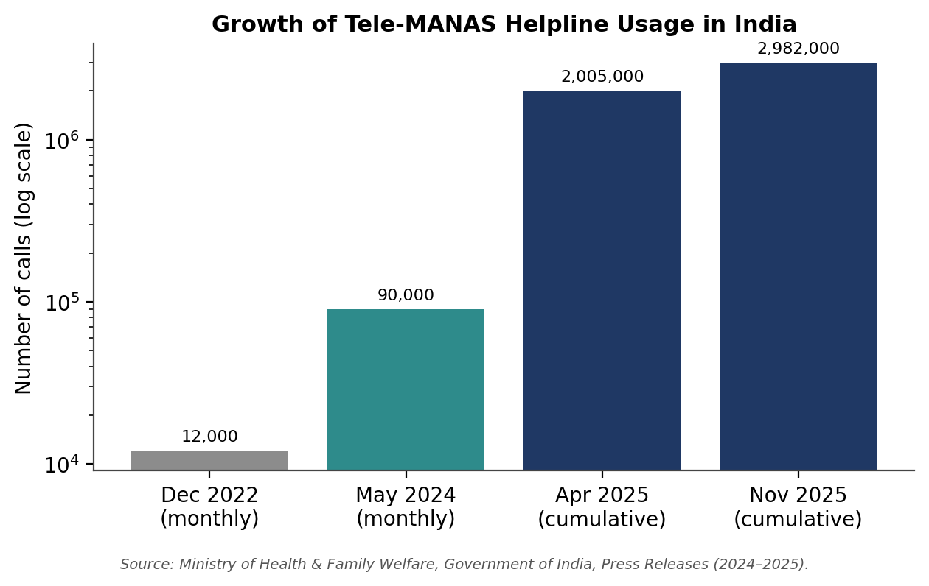
Figure 3. Growth in Tele-MANAS helpline usage, December 2022 – November 2025 (log scale). Source: Ministry of Health & Family Welfare, Government of India, press releases (2024–2025).
Tele-MANAS has real value for students and rural populations who face geographical or financial barriers to in-person care, and its rapid growth suggests genuine, rising demand. However, it should be seen as a first point of contact rather than a substitute for specialized, ongoing clinical treatment for severe conditions.

5.6 Mental Health in Educational Institutions
The National Education Policy (NEP), 2020 places explicit emphasis on holistic development and student wellbeing, which gives institutions a policy basis for building counselling support (Ministry of Human Resource Development, 2020). Complementing this, the Ministry of Health and Family Welfare's RKSK has, since 2014, brought mental health into a wider adolescent health agenda through nearly 8,000 Adolescent Friendly Health Clinics and close to a million peer educators nationwide (Ministry of Health and Family Welfare, 2014; UNICEF India, 2026b). In practice, many schools, colleges and universities still lack enough trained counsellors or well-informed staff to fully act on this vision.

5.7 Youth Mental Health and the Sustainable Development Goals
India's youth mental health agenda also connects directly to its global commitments under the 2030 Agenda for Sustainable Development (United Nations, 2015). Five Sustainable Development Goals (SDGs) are especially relevant to the arguments made in this paper:
- SDG 3 (Good Health and Wellbeing): Target 3.4 explicitly calls for promoting “mental health and wellbeing” and reducing premature mortality from noncommunicable causes by one-third, with suicide mortality as a formally tracked indicator (“Meeting the UN Sustainable Development Goals,” 2023; United Nations Department of Economic and Social Affairs, n.d.).
- SDG 4 (Quality Education): Inclusive, equitable education depends on students' emotional wellbeing; school-based mental health literacy and counselling directly support learning outcomes and retention.
- SDG 5 (Gender Equality): Addressing the distinct pressures young women face, online harassment, safety concerns and unequal opportunity, is inseparable from the broader goal of gender equality.
- SDG 10 (Reduced Inequalities): Closing the rural–urban and gender gaps in access to mental healthcare is fundamentally a question of reducing inequality within the country (Izutsu et al., 2015).
- SDG 16 (Peace, Justice and Strong Institutions): The Mental Healthcare Act, 2017 and Tele-MANAS represent exactly the kind of accountable, rights-respecting institutions that SDG 16 envisions for vulnerable populations.
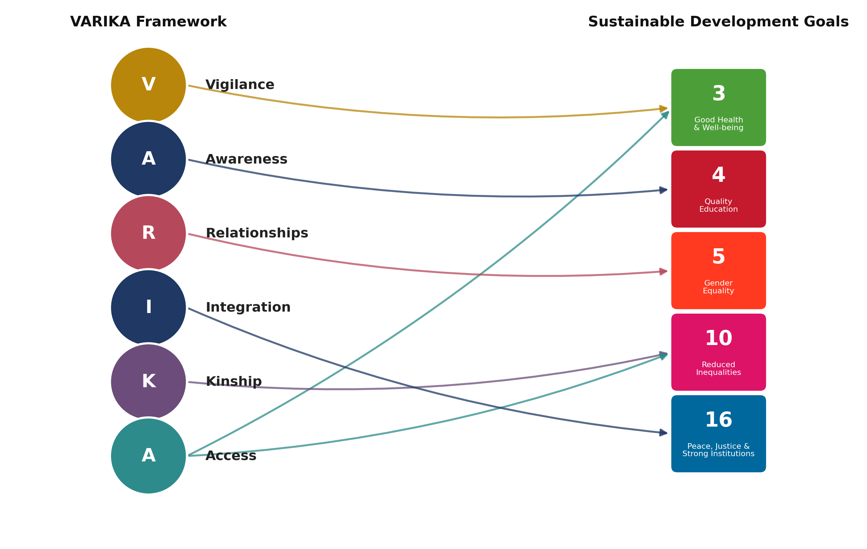
Figure 4. Mapping the VARIKA Framework's six pillars onto five related Sustainable Development Goals. Author's own synthesis.
Framing youth mental health as part of India's SDG commitments gives the issue an international benchmark to work towards and connects domestic policy (NMHP, DMHP, MHCA, Tele-MANAS, NEP 2020) to a broader, time-bound global accountability framework.

5.8 Policy Gaps and Emerging Challenges
- Uneven distribution of mental health professionals across states and districts.
- Weak service availability in rural and remote regions.
- Persistent stigma that discourages early help-seeking.
- Limited mental health literacy among the general public, teachers and parents.
- Thin campus counselling infrastructure in many institutions.
- Weak coordination between the education and healthcare sectors.
- Financial barriers to sustained, specialized treatment, despite the MHCA's insurance-parity provision.
- Need for stronger, independent monitoring and outcome evaluation of existing schemes.

5.9 International Good Practices
Several countries have folded mental healthcare into schools, universities and primary healthcare rather than treating it as a separate specialty. Common elements include school-based counselling, mental health content in the curriculum, community outreach, digital counselling platforms and structured youth participation in policy design (World Health Organization & UNICEF, 2022), approaches India can adapt, not copy directly, given its scale and diversity.
Table 5. Overview of Major Mental Health Initiatives in India
Program | Launched | Focus | Key Data Point
National Mental Health Program (NMHP) | 1982 | Integrating mental healthcare into general health system | National framework; uneven state-level implementation
District Mental Health Program (DMHP) | 1996 | Decentralized, district-level service delivery | Operating in most districts; professional shortages remain
Mental Healthcare Act (MHCA) | 2017 / in force 2018 | Rights-based mental healthcare law; decriminalizes suicide | Insurance parity mandated; state-level rollout still uneven
Rashtriya Kishor Swasthya Karyakram (RKSK) | 2014 | Holistic adolescent health incl. mental health, in/out of school | ~8,000 Adolescent Friendly Health Clinics nationwide
National Tele Mental Health Program (Tele-MANAS) | Oct 2022 | Free 24/7 tele-counselling in 20 languages | 29.82 lakh cumulative calls handled by Nov 2025
National Education Policy (NEP) | 2020 | Holistic development & student wellbeing in education | Policy basis for school/college counselling support

Critical Analysis
India has shown real policy commitment through NMHP, DMHP, the Mental Healthcare Act and Tele-MANAS, and Tele-MANAS in particular has demonstrated that demand for mental health support is far higher than previously visible. But policy success cannot be measured only by the number of schemes or laws introduced. Implementation quality, workforce development, inter-sectorial coordination and measurable outcomes matter just as much, and these remain the weaker links in India's current system (“Bridging the Mental Health Treatment Gap,” 2025).
Key Findings
- India's mental health policy and legal framework has strengthened meaningfully over the last decade, from NMHP to the rights-based MHCA.
- Tele-MANAS has proven that digital channels can absorb large, previously hidden demand.
- Rural areas remain under-served despite policy attention.
- Schools and colleges need stronger counselling infrastructure to match NEP 2020's ambitions.
- Youth mental health is directly linked to India's SDG 3, 4, 5, 10, and 16 commitments, giving it an international accountability dimension.
- Long-term success depends on implementation and coordination, not just new program launches.

6. POLICY RECOMMENDATIONS AND A PROPOSED FRAMEWORK

6.1 Introduction
The evidence gathered in this paper points to one central idea: India's mental health system needs to shift from reacting to crises towards preventing them. Figure 5 draws together the challenges, impacts, protective factors and policy responses discussed in Sections 3 to 5 into a single conceptual model, before the recommendations and the VARIKA Framework are introduced.
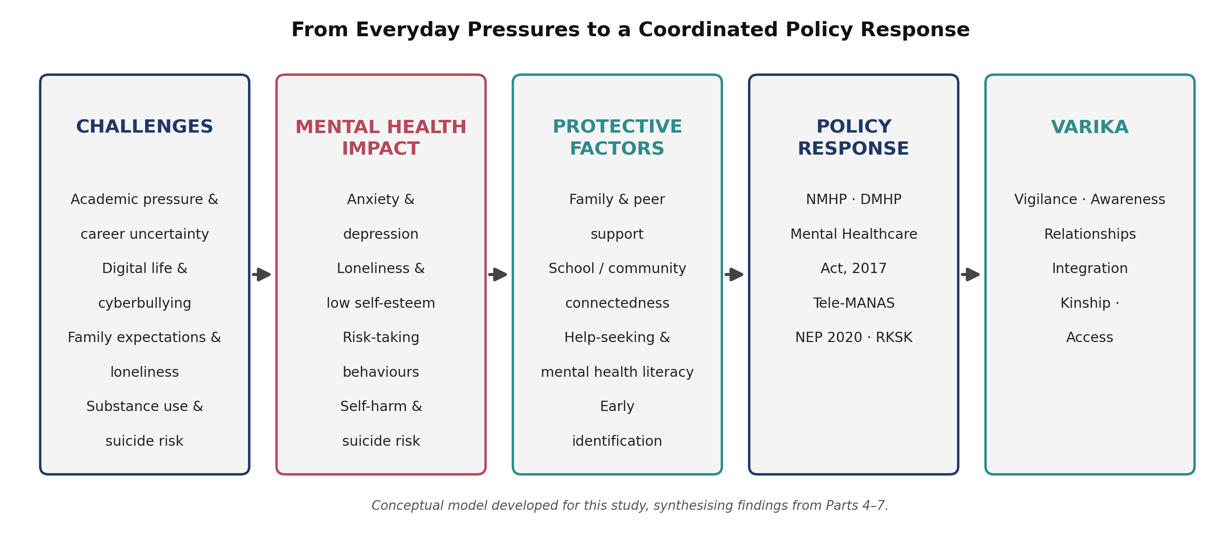
Figure 5. Conceptual model linking everyday challenges to mental health impact, protective factors, policy response and the proposed VARIKA Framework. Author's own synthesis, based on the evidence reviewed in this paper.

6.2 Policy Recommendations

1. Strengthen Mental Health Education
Make age-appropriate mental health literacy, covering stress management, emotional resilience, healthy digital habits and help-seeking, a standard part of school and college curricula, not an occasional workshop.

2. Expand Accessible Counselling Services
Set up professionally staffed, confidential counselling centers in every college and university, with particular priority given to institutions in rural and under-served regions.

3. Promote Community-Based Mental Health
Train and involve local volunteers, youth groups, teachers and primary healthcare workers so that mental health support does not depend on hospitals and clinics alone.

4. Build Gender-Responsive Programs
Design counselling services, safety mechanisms and awareness campaigns that respond specifically to the pressures young women face, including online harassment and the practical help-seeking barriers outlined in Section 4.1.1, while also addressing the stigma that keeps young men from seeking help until a crisis point.

5. Invest in Digital Wellbeing and Cyber Safety
Combine mental health education with digital literacy: screen-time awareness, responsible social media use, and clear, well-publicized reporting routes for cyberbullying and online harassment.

6. A Dedicated Rural Implementation Pathway
Rural mental healthcare needs more than a general commitment to “expand services”, it needs its own delivery pathway, built around the specific barriers identified in this paper (Sections 4.2 and 4.2.1). A tiered, community-first model is recommended:
- Village level: train and equip existing RKSK peer educators, ASHA workers and self-help group members to recognize early distress and make first-contact referrals, so support does not depend on a rural family travelling before anyone is even aware help exists.
- Block/taluka level: deploy mobile or periodic outreach counselling clinics, with at least one female counsellor rotating through each cluster, directly addressing the reluctance of rural young women to consult a male counsellor about personal matters.
- District level: strengthen DMHP referral linkages so that cases needing specialist care have a clear, funded pathway from village to block to district, rather than an informal or word-of-mouth route.
- Digital layer: pair Tele-MANAS with shared community access points (schools, primary health centers, women's self-help group meetings) for young women and families with limited private smartphone or internet access, rather than assuming individual digital access is equal across genders.
- Family and community engagement: work through panchayats, women's self-help groups and school parent-committees to gradually shift norms around stigma, mobility and permission-seeking, since infrastructure alone cannot resolve social barriers to help-seeking.

7. Encourage Youth Participation
Involve young people as active partners, not just recipients, in designing awareness campaigns, peer-support systems and policy consultations.

6.3 Proposed Framework: The VARIKA Framework
Building on the findings of this paper, an original six-pillar framework, VARIKA, is proposed for guiding future policy and program design. VARIKA stands for Vigilance, Awareness, Relationships, Integration, Kinship, and Access, six dimensions that, this paper argues, must move together rather than being pursued as separate, disconnected efforts.
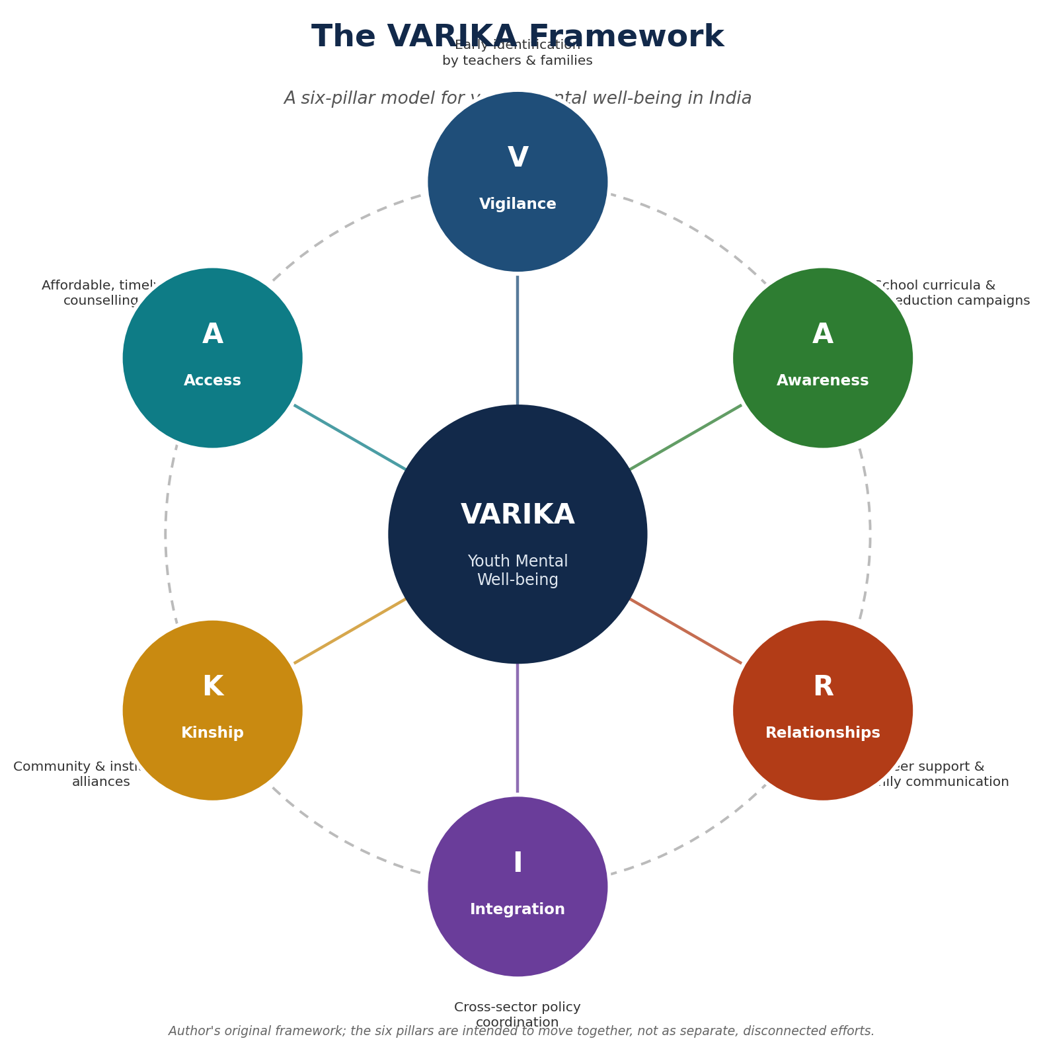
Figure 6. The VARIKA Framework, a six-pillar model for youth mental wellbeing in India. Author's original conceptual framework, informed by the findings of this study.
In practice: Vigilance means training teachers, parents, and health workers to spot early signs; Awareness means school/college curricula and public campaigns that reduce stigma; Relationships means peer-support groups, family communication, and teacher-mentors; Integration means linking health, education, rural development, and digital policy under one coordinated agenda; Kinship means partnerships between schools, local government, volunteers, and NGOs that build community resilience; and Access means campus counsellors, expanded Tele-MANAS, and rural outreach. Unlike a single scheme, VARIKA is meant as a coordinating lens, a way to check whether a new program genuinely strengthens all six pillars together, rather than just one in isolation.

6.3.1 Framework Validation and Comparative Positioning
The VARIKA Framework is proposed as a conceptual synthesis derived from the findings of the present review, intended to provide a structured, context-sensitive approach to adolescent mental health promotion in India. Although the framework has not yet undergone formal empirical validation, its components were systematically aligned with recommendations from established global frameworks, including the World Health Organization and UNICEF’s Helping Adolescents Thrive (HAT) program, as well as with evidence synthesized from the reviewed literature (World Health Organization & UNICEF, 2022). This comparative alignment indicates that VARIKA incorporates internationally recognized principles, such as early intervention, family engagement, school-based support, community participation and multi-sectorial collaboration, while extending them through a framework specifically tailored to the Indian socio-cultural context. Future research should validate the framework through expert consultation, such as a Delphi technique, stakeholder feedback and pilot implementation across educational and community settings.
This alignment rests on three elements:
- Comparative mapping against the HAT program, summarized in Table 6 below.
- Informal grounding in practitioner experience, the field consultations reported in Section 3.3 independently pointed to stigma-driven help-seeking barriers (addressed by the Vigilance and Awareness pillars) and family-attitude barriers (addressed by the Relationships pillar), consistent with VARIKA’s structure.
- A defined pathway to formal validation, set out below, so that the framework’s current status is transparent to readers and future researchers.

WHO Helping Adolescents Thrive (HAT) | VARIKA Framework Pillar
Early intervention | Vigilance
School-based mental health | Awareness
Family engagement | Relationships
Multi-sectorial collaboration | Integration
Community support | Kinship
Continuous care and monitoring | Access
Table 6. Mapping the VARIKA Framework’s pillars onto the WHO/UNICEF Helping Adolescents Thrive (HAT) program elements. Author’s own synthesis.
Planned validation steps for the VARIKA Framework include:
- Delphi consultation with adolescent mental health, education and public policy experts to refine and confirm the six pillars.
- Pilot implementation in school and community settings, for example a state-level pilot such as in Haryana, to test feasibility and early outcomes.
- Rural versus urban comparative testing, to check whether the framework performs consistently across geographic and resource contexts.
- Quantitative validation using structural equation modelling (SEM) or partial least squares (PLS) to test the relationships between pillars and youth mental health outcomes.
- State-level policy adaptation studies, examining how the framework could be customized to different states’ administrative and cultural contexts.

6.4 Practical Implications by Stakeholder
Stakeholder | Immediate Priorities
Policymakers | Strengthen preventive policy; expand rural mental healthcare; increase youth mental health funding
Educational institutions | Expand counselling services; introduce mental health literacy; support peer-support groups
Communities & families | Reduce stigma; encourage open conversation; support local awareness campaigns
Researchers | Conduct rural and gender-specific studies; evaluate Tele-MANAS and NMHP outcomes over time

7. CONCLUSION, LIMITATIONS, AND FUTURE SCOPE

7.1 Conclusion
Youth mental health in India is shaped by a web of interconnected factors, academic pressure, career uncertainty, digital life, family expectations, loneliness and unequal access to care, rather than any single cause. Supportive families, inclusive schools, resilient communities and responsive public policy act as counterweights to these pressures.
The comparisons in this paper show that policy cannot be one-size-fits-all: boys and girls face different and shifting risks, rural and urban youth face different barriers to care, and today's generation faces a different mix of stress and awareness than the generation before it. India has made genuine progress through NMHP, DMHP, and Tele-MANAS, but stronger implementation, better coordination and sustained investment in prevention are what will turn that progress into lasting change. A mentally healthy generation is better placed to learn, work, lead, and build, which makes youth mental health not a side issue, but a core part of India's development story.
Investing in youth mental health is therefore not merely a public health priority, but a long-term investment in India's human capital, social resilience and inclusive development. The choices India makes now, in classrooms, clinics, communities and policy, will shape not only how the next generation copes with distress, but how confidently it builds the country's future.

7.1.1 Contribution of the Study
This paper contributes to the literature in four ways:
- it integrates psychology, education, gender, rural development and public policy into a single, India-focused review of youth mental health;
- it introduces practice-based grounding through illustrative practitioner reflections, connecting secondary evidence to field-level experience;
- it proposes the VARIKA Framework as an original, India-specific conceptual model, positioned against an established global framework; and
- it sets out specific, testable directions for future research and policy validation, discussed in Sections 6.3.1 and 7.3.

7.2 Limitations of the Study
Given its reliance on secondary sources (see Section 2 for methodology), this paper's findings are only as current and complete as those sources allow. It focuses mainly on the Indian context and does not attempt a detailed country-by-country comparison. Because mental health data and policy in India continue to evolve quickly, some figures in this paper may be updated in newer reports after publication.

7.3 Future Scope of Research
- Primary studies involving school and university students directly.
- Comparative rural–urban and gender-specific intervention research.
- Digital wellbeing, responsible technology use and AI-assisted mental health tools among youth.
- Mental health literacy among teachers and parents.
- Independent, longitudinal evaluation of Tele-MANAS, the Mental Healthcare Act and related programs.
- Comparative policy analysis between India and other developing countries.
- Delphi-based expert validation of the VARIKA Framework, followed by pilot implementation in specific school or community settings, for example a state-level pilot such as in Haryana.
- Rural versus urban comparative testing of the VARIKA Framework's six pillars, to establish whether they hold consistently across geographic and resource contexts.
- Quantitative validation of the framework's pillar relationships using SEM or PLS techniques.
- State-level policy adaptation studies examining how the framework could be customized to different states' administrative and cultural contexts.
Future studies should prioritize longitudinal and mixed-method research to evaluate the long-term effectiveness of community-based mental health interventions.

Author's Perspective
Mental health is not simply the absence of illness. It is tied to dignity, opportunity, meaningful relationships, and a young person's ability to grow into who they are meant to be. While working on this paper, one idea kept coming back: awareness alone is not enough. Young people need families who listen, institutions that respond with empathy rather than judgment, accessible professional help, and policies that treat emotional wellbeing as a basic part of human development, not an afterthought.
I believe lasting change will come from collaboration, not isolated effort, from teachers, healthcare workers, policymakers, parents, and communities each doing their part to make it safe for a young person to ask for help. Platforms like Youth Vision India can play a real role here, working alongside educators, psychologists, volunteers and local communities to build the everyday conversations and coordinated support that this paper argues India urgently needs. India's future depends not only on an educated youth, but on a mentally healthy, connected and resilient one.
Data Availability Statement
This study is based primarily on publicly available secondary data. It also includes a small number of informally collected practitioner quotes, used illustratively rather than as a formal primary dataset; no systematic new dataset was generated or analyzed.
Conflict of Interest
The author declares no conflict of interest.
Funding Statement
No external funding was received for this research.

Acknowledgement
The author gratefully acknowledges the researchers, institutions, government agencies and international organizations whose published data and reports made this study possible, and thanks Youth Vision India for providing a platform for youth-centered, evidence-based research and dialogue.
“A nation's greatest strength lies not only in the knowledge of its young people, but also in their emotional wellbeing, resilience, compassion and hope. Building mentally healthy youth is therefore not merely a health objective, it is a shared responsibility toward a stronger, more inclusive and sustainable future for India.”

References
Balamurugan, G., Sevak, S., Gurung, K., & Vijayarani, M. (2024). Mental health issues among school children and adolescents in India: A systematic review. Cureus, 16(5), e61035. https://doi.org/10.7759/cureus.61035
Bridging the mental health treatment gap in India: A policy-oriented framework using the care cascade approach. (2025). Indian Journal of Psychological Medicine. https://pmc.ncbi.nlm.nih.gov/articles/PMC12468826/
Central Mental Health Law and Policy Project. (2026). Know your mental health rights in India: Understanding the Mental Healthcare Act, 2017. https://cmhlp.org/
Cyberbullying Research Center. (2023). Cyberbullying research in India. https://cyberbullying.org/research/map/india
Data Reportal. (2025). Digital 2025: India. Kepios / We Are Social / Meltwater. https://datareportal.com/reports/digital-2025-india
Desai, S. (2017). Adolescent health: Priorities and opportunities for Rashtriya Kishor Swasthya Karyakram (RKSK) in Uttar Pradesh. Population Council. https://knowledgecommons.popcouncil.org/
Duffy, R. M., & Kelly, B. D. (2017). Concordance of the Indian Mental Healthcare Act 2017 with the World Health Organization's checklist on mental health legislation. International Journal of Mental Health Systems, 11, 48. https://doi.org/10.1186/s13033-017-0155-1
Gao, J., & Gao, L. (2024). A meta-analysis of prospective cohort studies on screen time and the risk of depression in adolescents. Journal of Psychiatric Research. https://doi.org/10.1016/j.jpsychires.2024.10.019
GrabOn. (2026). Internet statistics in India: Usage and penetration rate (2026). https://www.grabon.in/indulge/tech/internet-users-statistics/
Gururaj, G., Varghese, M., Benegal, V., Rao, G. N., Pathak, K., Singh, L. K., ... NMHS Collaborators Group. (2016). National Mental Health Survey of India, 2015–16: Prevalence, patterns and outcomes (NIMHANS Publication No. 129). National Institute of Mental Health and Neurosciences.
IC3 Institute. (2024). Student suicides: An epidemic sweeping India (Volume 2). https://ic3institute.org/
Izutsu, T., Tsutsumi, A., Minas, H., Thornicroft, G., Patel, V., & Ito, A. (2015). Mental health and wellbeing in the Sustainable Development Goals. The Lancet Psychiatry, 2(12), 1052–1054. https://doi.org/10.1016/S2215-0366(15)00457-5
Malhotra, S., & Patra, B. N. (2014). Prevalence of child and adolescent psychiatric disorders in India: A systematic review and meta-analysis. Child and Adolescent Psychiatry and Mental Health, 8, 22. https://doi.org/10.1186/1753-2000-8-22
Mapping of geographic inequality in mental health care facilities and psychiatrists' distribution across seven districts of Indore division: A geospatial analysis from central India. (2025). National Library of Medicine. https://pmc.ncbi.nlm.nih.gov/articles/PMC12574762/
Meeting the UN Sustainable Development Goals for mental health: Why greater prioritization and adequately tracking progress are critical. (2023). World Psychiatry, 22(2), 325–326. https://doi.org/10.1002/wps.21090
MHFA India. (2026). Mental Healthcare Act 2017: How India's law changed. https://www.mhfaindia.com/blog/mental-healthcare-act-2017-india-mental-health-law
Ministry of Health and Family Welfare, Government of India. (2014). Rashtriya Kishor Swasthya Karyakram (RKSK) operational framework. https://nhm.gov.in/
Ministry of Health and Family Welfare, Government of India. (2025). Update on the National Tele Mental Health Programme (Tele-MANAS). https://www.mohfw.gov.in/
Ministry of Human Resource Development, Government of India. (2020). National Education Policy 2020. https://www.education.gov.in/
National Crime Records Bureau. (2021). Accidental deaths & suicides in India (ADSI) 2021. Ministry of Home Affairs, Government of India. https://www.data.gov.in/
National Crime Records Bureau. (2022). Accidental deaths & suicides in India (ADSI) 2022. Ministry of Home Affairs, Government of India. https://www.data.gov.in/
Parliament of India. (2017). The Mental Healthcare Act, 2017 (Act No. 10 of 2017). https://www.indiacode.nic.in/
Predictors, prevalence, and patterns of cyberbullying among school-going adolescents. (2023). Indian Journal of Psychiatry, 65(7). https://journals.lww.com/indianjpsychiatry/
Prevalence of mental health problems among rural adolescents in India: A systematic review and meta-analysis. (2022). Scientific Reports, 12, Article 16714. https://doi.org/10.1038/s41598-022-19731-2
Ranjith, P. J., Jayakumar, C., Kishore, M. T., Binukumar, B., & Bhaskar, A. (2019). Association between bullying, peer victimization and mental health problems among adolescents in Bengaluru, India. Indian Journal of Social Psychiatry, 35, 207. https://doi.org/10.4103/ijsp.ijsp_39_18
Saraceno, B., & de Almeida, J. M. C. (2022). An outstanding message of hope: The WHO World Mental Health Report 2022. Epidemiology and Psychiatric Sciences, 31, e51. https://doi.org/10.1017/S2045796022000373
Silent Screams: A narrative review of cyberbullying among Indian adolescents. (2024). PMC. https://www.ncbi.nlm.nih.gov/pmc/articles/PMC11376467/
The effects of cyberbullying victimization on depression and suicidal ideation among adolescents and young adults: A three-year cohort study from India. (2022). Child Abuse & Neglect. https://www.ncbi.nlm.nih.gov/pmc/articles/PMC9461154/
The George Institute for Global Health. (2026a). Barriers and facilitators for accessing mental health care and support for adolescents in India: A systematic review. SSM – Mental Health. https://pmc.ncbi.nlm.nih.gov/articles/PMC12430854/
The George Institute for Global Health. (2026b, June). Systematic review identifies key barriers preventing Indian adolescents from seeking mental health care. MedicalXpress. https://medicalxpress.com/news/2026-06-systematic-key-barriers-indian-adolescents.html
UNICEF India. (2024). Child and adolescent mental health service mapping: India 2024. https://www.unicef.org/india/reports/child-and-adolescent-mental-health-service-mapping-india-2024
UNICEF India. (2026a). Adolescent health and development. https://www.unicef.org/india/topics/adolescent-health-and-development
UNICEF India. (2026b, May). Government of India, UNICEF and partners put youth voices at the centre of mental health action for adolescents. https://www.unicef.org/india/press-releases/
UNICEF. (2021). The state of the world's children 2021: On my mind – Promoting, protecting and caring for children's mental health. https://www.unicef.org/reports/state-of-worlds-children-2021
United Nations Department of Economic and Social Affairs. (n.d.). Goal 3: Ensure healthy lives and promote well-being for all at all ages. https://www.un.org/sustainabledevelopment/health/
United Nations. (2015). Transforming our world: The 2030 Agenda for Sustainable Development. https://sdgs.un.org/2030agenda
Verma, R., & Kumar, A. (2024). Mental health services in rural India: A big challenge still to be met. BJPsych International. https://doi.org/10.1192/bji.2024.23
World Health Organization & UNICEF. (2022). Helping Adolescents Thrive (HAT): Joint programme on mental health and psychosocial well-being of adolescents. https://www.who.int/teams/mental-health-and-substance-use/
World Health Organization. (2019). Suicide worldwide in 2019: Global health estimates. https://www.who.int/publications/i/item/9789240026643
World Health Organization. (2021). Adolescent mental health. https://www.who.int/news-room/fact-sheets/detail/adolescent-mental-health
World Health Organization. (2022). World mental health report: Transforming mental health for all. https://www.who.int/publications/i/item/9789240049338
World Health Organization. (2024, November). Transforming adolescent health: WHO's comprehensive report on global progress and gaps. https://www.who.int/
Note. Referenced in APA (7th edition) style. All figures should be verified against the latest official releases before final publication, as government data (especially Tele-MANAS and NCRB figures) are updated periodically.

